

GAM271 Statement of Intent Template (Level Design)

This template should be used for GAM271 Ass 1
Note that there is no word limit. Note that sections below can be resized as you see fit, but as a guide you should probably aim for around 1000-1500 words. Try to be as succinct and to the point as possible.
You are to write a 'Statement of Intent' for your project. This should be considered partially as a 'Pitch' that 'sells' the viability (Commercial or otherwise) of your project concept.
Your report should outline:
- What form your Level Design is intended to take.
- What engine/game is it crafted for
- Do you already have experience with this engine/game and to what degree (playing and level design/modding)
- What research into this project have you undertaken.
- An initial quick sketch of the level’s structure and list of what you intend to make. (Including time scales).
- A list of project risks - what could go wrong and how could you ameliorate those risks?

Note1: Changes during development - It is fully expected that your project will change over the course of the module as you learn more about the problems you will experience and find out what works and doesn't work. This reflection and Iteration is natural and, along with any deviations or changes to your original 'statement of intent' should also be recorded as part of Assignment 2. Any changes between the original 'Statement of intent' and the final submission should be fully explained in your ‘Development Journal’.
Note 2: The range of possible projects - this covered in more detail in the Assignment brief and will be extensively discussed in class.
Whatever you choose to make should be discussed and ‘greenlit’ by one of your tutors.

Title of Project:
Miner’s Requiem
By Ellie Smith
Outline of project
Single line descriptor and engine

A mine that’s been taken over by a demon army that the player must reclaim. I’ll use the Trench Broom level editor for Quake 1

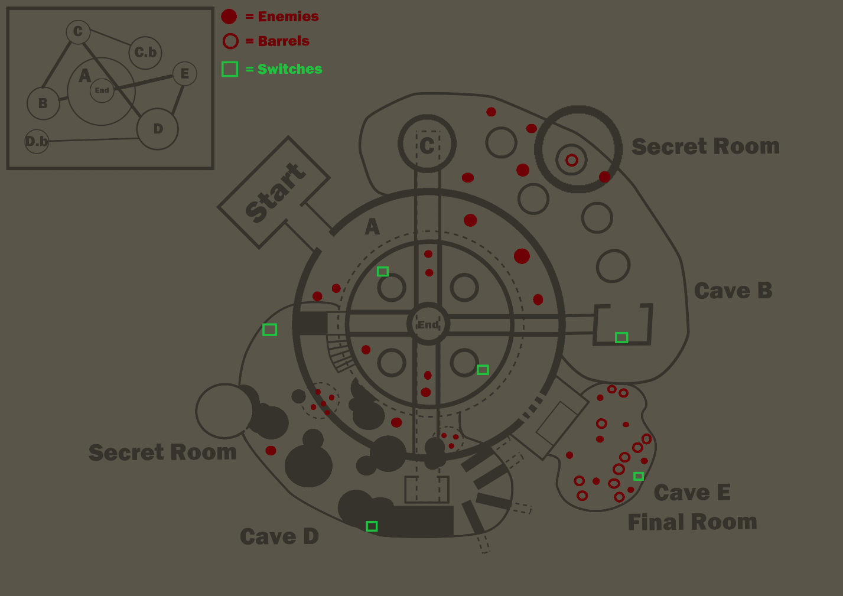

Audience and Demographics
Quake is rated as a Mature [17+] game. I found an esports site with some demographics on it, which gave a heat map of the age’s of active players in the esports quake scene.

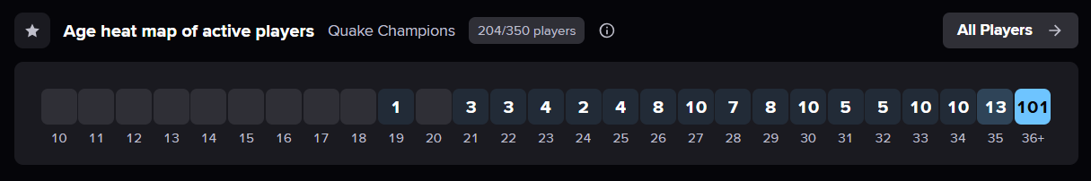

https://escharts.com/games/quake

This suggests that most players are 36+, which makes sense since Quake is a fairly old game however we can’t assume this is true for the main game. Steam’s statistics suggest there’s still a consistent player base of around 70 players on average per day player Quake, which doesn’t include the statistics for all the other Quake games. Many websites report that the age rage with the largest number of Steam users is the 20-29 age bracket so Quake still attracts a new audience despite its longevity.

https://steamcharts.com/app/2310
https://www.coolest-gadgets.com/steam-statistics/#:~:text=A%20large%20group%20of%20Steam,to%20US%20%2418.78%20by%202028.
https://sidetrain.com/guides/steam-user-demographic-statistics
https://www.skillademia.com/statistics/steam-statistics/

As a result I need to make sure my level fulfils the wants of these two particular groups.

Risk

Quake modding info:
https://steamcommunity.com/sharedfiles/filedetails/?id=2635180062#:~:text=Another%20type%20of%20modding%20you,use%20some%20kind%20of%20tool.

Its unknown how long it will take me to learn QuakeC to be able to create the mechanics I want exactly however having looked briefly at some tutorials I don’t think it will be too dissimilar to learning C# so I’m not too worried. However, to mitigate the risk I’ll dedicate a week after blocking out the level to learning and implementing the mechanics I’d like. If its not working after the week then I’ll scrap the ideas.

I know I can swap the assets out with custom ones and I’m pretty sure I can import my own textures / meshes however I’ll make sure to learn this in the first sprint. I’ll also need to be wary of any pathing issues that could occur from swapping the meshes.

I’m a bit concerned there isn’t enough backtracking within the level plan although it might already be a bit too long. After creating the blockout I’ll have playtested the level at least twice. I will review the plan then and if the level doesn’t feel hostile enough I’ll review the size / amount of backtracking at that point.

Research and reference projects:
List here any references to existing material (e.g. Game design principles, Games, Game levels, Mechanics, Software, Narrative, Lore, music/audio examples etc. that you have used as reference.

Animal Well – Level Design:
Animal Well. 2024. Shared Memory LLC, Bigmode Games.

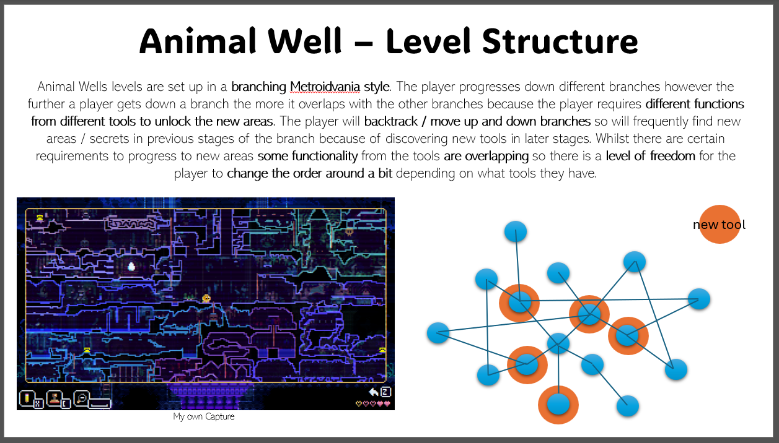

When playing through and discovering the secrets feature in Quake / Doom, it reminded me a lot of Animal Well since secrets are a fundamental pillar of the game. When players walk into a room in Animal Well even one, they’ve been through loads of times already they look with suspicion and curiosity because the likelihood is there’s probably a secret the player hasn’t discovered yet still waiting in the room. I want to replicate this experience for the player by further pushing the secrets / trap design within Quake.

Legend Of Zelda: Puzzle Box Dungeons – Puzzle Design:
How Zelda’s Puzzle Box Dungeons Work [Film]. 2020. Available at: https://www.youtube.com/watch?v=pwHqY_4nsJ4 [accessed 13 Feb 2025].

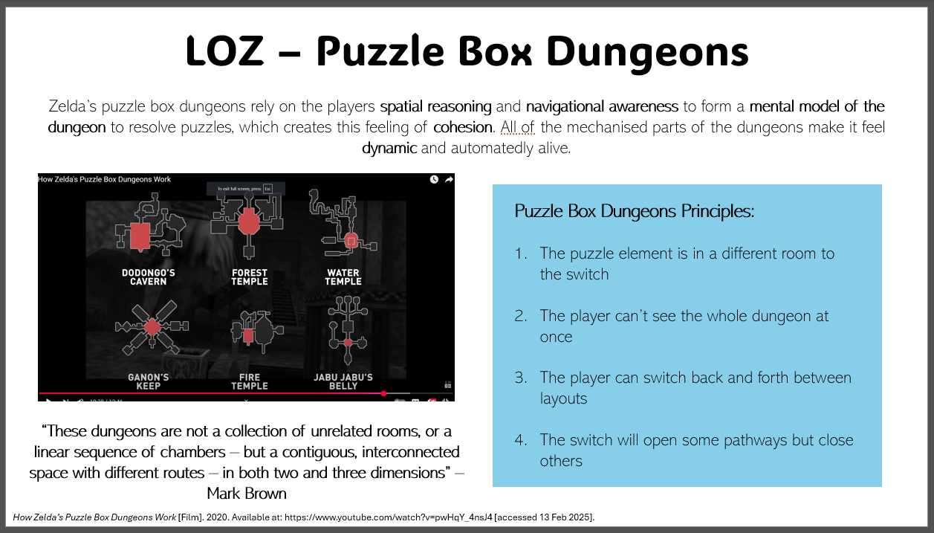

Quake / Doom lean on this idea of the environment being just as hostile as the enemies, to make the player feel more isolated having to rely on their instincts and react quicker to changes in the environment as well as keeping an eye on enemies. Again, this is a theme within Quake I want to utilise / push further in my level. I investigated the design principles behind Zelda's puzzle box dungeons because of the way the dungeon dynamically responds to the player and forces them to build a mental model of the space they're in. The theme of mechanised movement also fits well with the industrial aesthetic of a Mine. By making the level feel alive I can reinforce the hostility of the environment, so the player feels they're having to escape from the environment as well as enemies.

Sandy Peterson - Trap Design:
[DOOM] Sandy Petersen’s Level Design [Film]. 2020. Available at: https://www.youtube.com/watch?v=w9oG2LBuMwY [accessed 13 Feb 2025].
‘(376) Dwars and Decino Talk to Sandy Petersen About Doom - YouTube’. 2025. [online]. Available at: https://www.youtube.com/watch?v=1Ss_gli8atM&list=LL&index=2 [accessed 14 Feb 2025].
‘(381) Why Is Quake Like That? - YouTube’. 2025. [online]. Available at: https://www.youtube.com/watch?v=MUeu96TKQwU&list=LL&index=1 [accessed 14 Feb 2025].

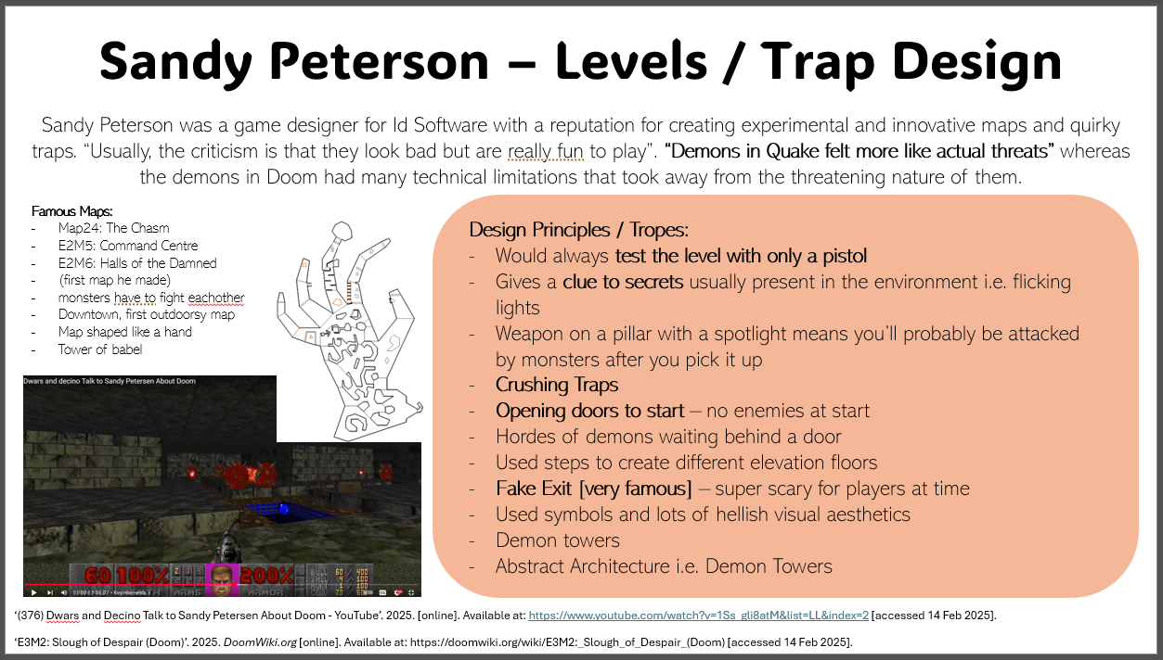

Sandy Peterson was one of the main designers to create the first levels in Doom / Quake and solidify their identities as hellish FPS games. I wanted to look at Sandy specifically because of his experimental approach that led to really interesting and famous traps / maps in the Doom / Quake genre. Most notably include his fake exit trap that scared most players that played doom at the time as well as Map9: Fortress of Mystery that contained so many enemies the player needed to get the two groups of demons to fight each other.

He's also really influenced by abstract themes / stories such as H.P Lovecraft, which heavily influences the visual aesthetics in the two games. By Petersons own admission Quake was based on John Carmack's DnD character so the game featured this crossover, where the fantasy world is crossing over to the real world. Monster design was heavily influenced by this for example the Ogre a traditionally fantastical character uses a chainsaw instead of a club and throws grenades. Whilst I want my level to very clearly communicate the mine theme, I want it to remain a faithful inspiration of the Quake style so will also feature this abstract crossover with fantastical elements. This could be realised in magical machinery or minerals with dangerous magical properties.

Greek Architecture:
‘Architectural Marvels: Decoding the Urban Design of Ancient Greece’. 2024. GHD [online]. Available at: https://www.greecehighdefinition.com/blog/2024/2/5/architectural-marvels-decoding-the-urban-design-of-ancient-greece [accessed 13 Feb 2025].
TOTTEN, Christopher W. 2014. An Architectural Approach to Level Design. Boca Raton: CRC Press.

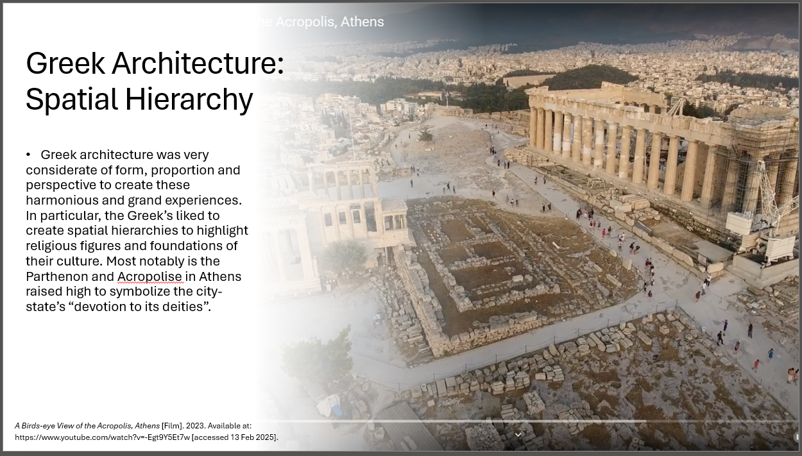

I've been reading, 'An Architectural Approach To Level Design' (Totten 2014), to improve my knowledge of level design. Particularly by looking at how to make my levels believable within the world they're in. Totten starts by delving into the history of architecture and how modular set and tropes were formed from different civilizations in the world. In particular I found Greek architectural tropes to be of inspiration to my level because of the attention to form and standardised proportions. I also wanted to look at the way the planners of the Athens Acropolis intentionally composed the space so that viewers would go on this journey to view the Parthenon three-dimensionally. To maintain the theme of dynamicism I want to incorporate into my level I want to be considerate of the players perspective and how their path will shape their approach and experience of the level.

Another important insight from the book is the triad of elements of level design; Usability, Delight and Functional Requirements and how they each influence each other.

In particular you should collect images for the following:
Reference images of similar maps – these should be in the style aimed for
Reference images of real world reference – e.g If a basement level – real basements from real buildings.

Artstation Environment Concepts / Blockouts Inspired by H.P.Lovecraft
https://www.artstation.com/artwork/rA5G1m
https://www.artstation.com/artwork/509lg
https://www.artstation.com/artwork/AlJblq
https://www.artstation.com/artwork/aRR09L
https://www.artstation.com/artwork/lV222Y
https://frogwares.com/urban-planning-lovecraftian-horror-first-steps/
https://www.artstation.com/artwork/283x4a
https://www.artstation.com/artwork/48OKdq
https://www.artstation.com/artwork/QXR423

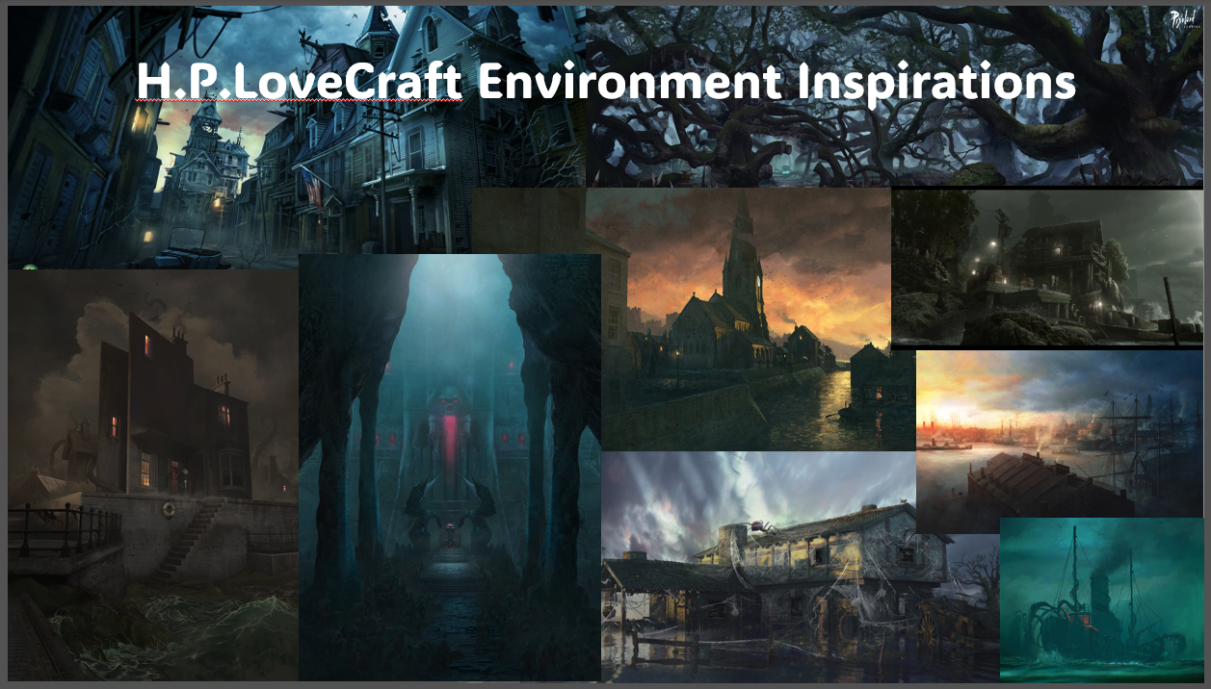

https://www.artstation.com/artwork/WBo5XE
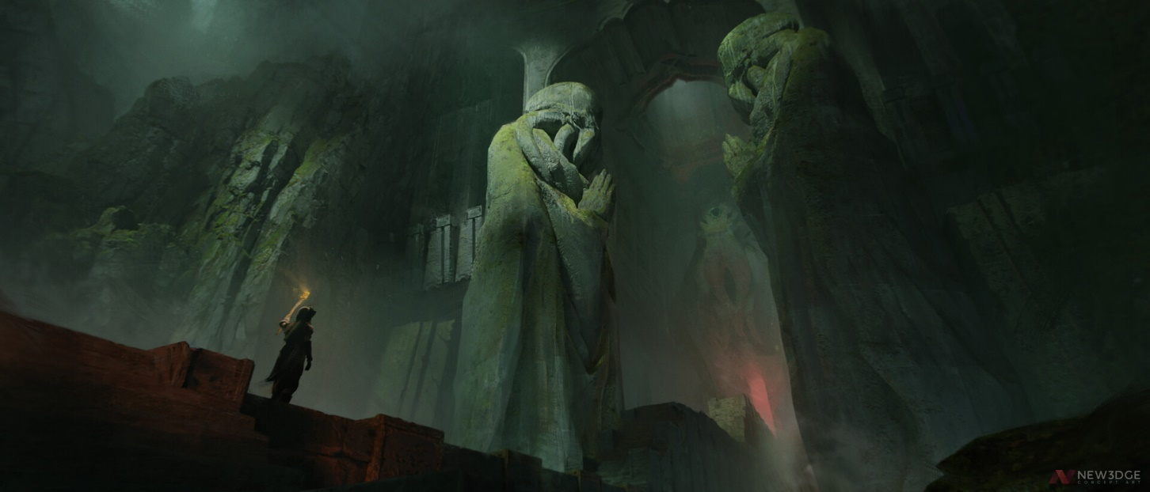

Google Maps Results for Mines in Cornwall
Over the next week or two I’d like to go out myself and explore a mine or two to collect primary research of the spaces and what it’s like to experience the spaces.

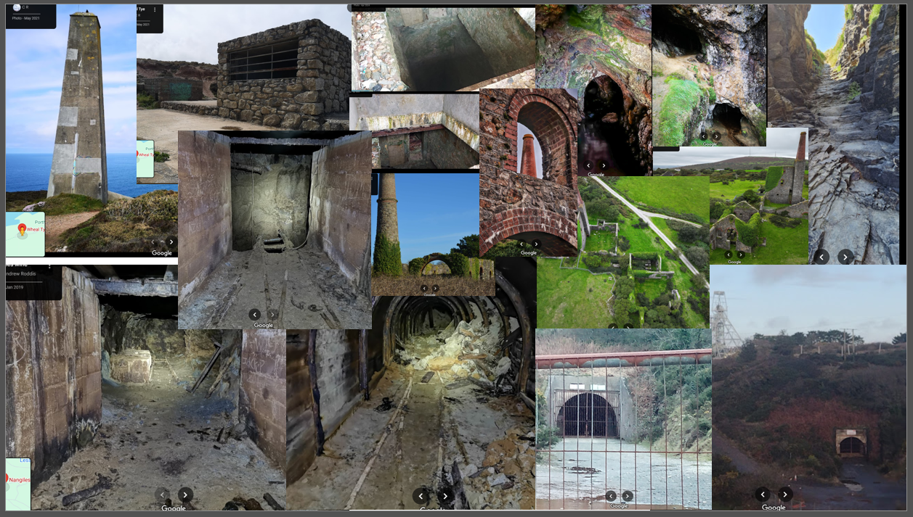

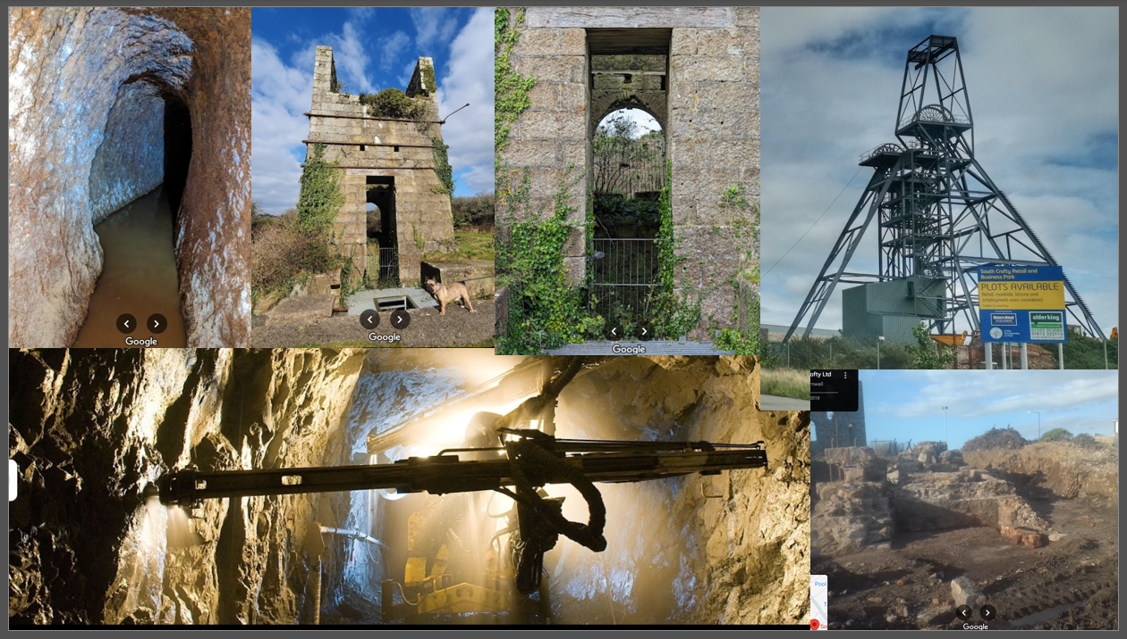

Rationale:
Outline here why you have chosen to undertake this particular project and what do you intend to get out of it?

In lots of modern games, developers can tend to place mechanics within a game because it’s conventional to do so rather than considering the advantages / disadvantages of doing so. I believe that, learning how design decisions were impacted by early computer technology and graphical capabilities will improve my own decision making and make me more aware of the consequences of my decisions.
I was initially drawn to Doom however decided on Quake instead, because the introduction of physics and the ability to jump has shaped the mechanics and systems within the FPS genre. Not only because its “more realistic” but because it creates more systematic gameplay and moment to moment choices.

As a portfolio piece I would also like to show off my ability to learn a new engine and research into a game’s pillars / USPs to ensure design decisions pull in the same direction.

Key indicators
Give between 1 and 3 key indicators that you consider your project should be marked against.
- How well does the level make the player feel as though they’re playing a true Quake map
- How well does the player feel the hostility of the environment
- How well does the level communicate a mine environment even if the player has never been to a mine in real life

Scope
Use this section to outline your project’s scope and a proposed timeline for your project, and list any key risks that you consider important

- My level will be 5-10 minutes long
- I’ll make at least one variation of the level in a different difficulty level
- I’ll make some sort of custom functionality for either an environmental or creature entity that is custom to the mine environment i.e. mining machinery or exploding minerals

I won’t be creating new art or audio assets so I’ll source free to use textures and assets other people have made that fit the theme of my level.

Sprint 1:
- Blockout the first half of the level [A / B / C]
- Add entities
- Playtest level

Sprint 2:
- Blockout second half of the level [D / E / Secret Rooms]
- Add entities
- Playtest Level
- Review hostility

Sprint 3:
- Learn QuakeC and try to create features
- Add textures

Sprint 4:
- Review Level
- Polish Level

Additions to gameplay
If possible, I’d like to learn how I can create new entities or reskin currently existing ones so I can create new events that enforce the hostility of the environment but reskinned to communicate the mine environment. For example minerals with different environmental consequences would be a fun addition.

